**Local Area Network (LAN) in Cisco Packet Tracer**

**LAB # 08**



**Spring 2022**

**CSE303L-Data Communication & Computer Network**

Submitted by: **Ashfaq Ahmad**

Registration No: **19PWCSE1795**

Class Section: **B**

“On my honor, as student of University of Engineering and Technology, I have neither given nor received unauthorized assistance on this academic work.”

Student Signature: ______________

Submitted to:

**Eng: Faizullah**

June 8, 2022

**Department of Computer Systems Engineering**

**University of Engineering and Technology, Peshawar**

**CSE 303L: Data Communication and Computer Networks**

|  |  |  |  |  |
| --- | --- | --- | --- | --- |
| **Demonstration of Concepts** | **Poor(Does not meet expectation (1))**  The student failed to demonstrate a clear understanding of the assignment concepts | **Fair(Meet Expectation (2-3))**  The student demonstrated a clear understanding of some of the assignment concepts | **Good (Exceeds Expectation (4-5)**  The student demonstrated a clear understanding of the assignment concepts | **Score**  **30%** |
| **Accuracy** | The student mis-configured enough network settings that the lab computer couldn't function properly on the network | The student configured enough network settings that the lab computer partially functioned on the network | The student configured the network settings that the lab computer fully functioned on the network | **30%** |
| **Following Directions** | The student clearly failed to follow the verbal and written instructions to successfully complete the lab | The student failed to follow the some of the verbal and written instructions to successfully complete all requirements of the lab | The student followed the verbal and written instructions to successfully complete requirements of the lab | **20%** |
| **Time Utilization** | The student failed to complete even part of the lab in the allotted amount of time | The student failed to complete the entire lab in the allotted amount of time | The student completed the lab in its entirety in the al | **20%** |

**Credit Hours:**

## Introduction

Cisco Packet Tracer is an innovative network simulation and visualization tool. This free software helps you to practice your network configuration and troubleshooting skills via your desktop computer or an Android or iOS based mobile device. Packet Tracer is available for both the Linux and Windows desktop environments.

With Packet Tracer you can choose to build a network from scratch, use a pre-built sample network, or complete classroom lab assignments. Packet Tracer allows you to easily explore how data traverses your network. Packet Tracer provides an easy way to design and build networks of varying sizes without expensive lab equipment.

**Task 01:** Make a LAN using HUB in Cisco Packet Tracer.

I made the LAN using HUB in which 2 PCs and 1 Laptop is connected. Then I gave IP to each PC because without IP they can’t communicate with each other. Then for checking its connectivity I sent PDU from PC0 to laptop0.

PC0 first sent message to Hub

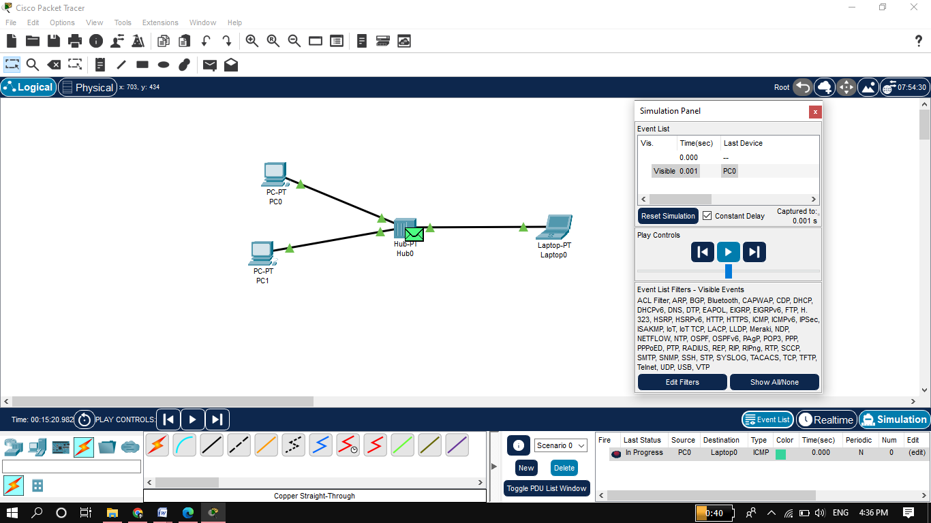

As HUB always broadcast the message so it sent the message to all devices connected to it. But laptop0 only accepted because we want to send to laptop0.

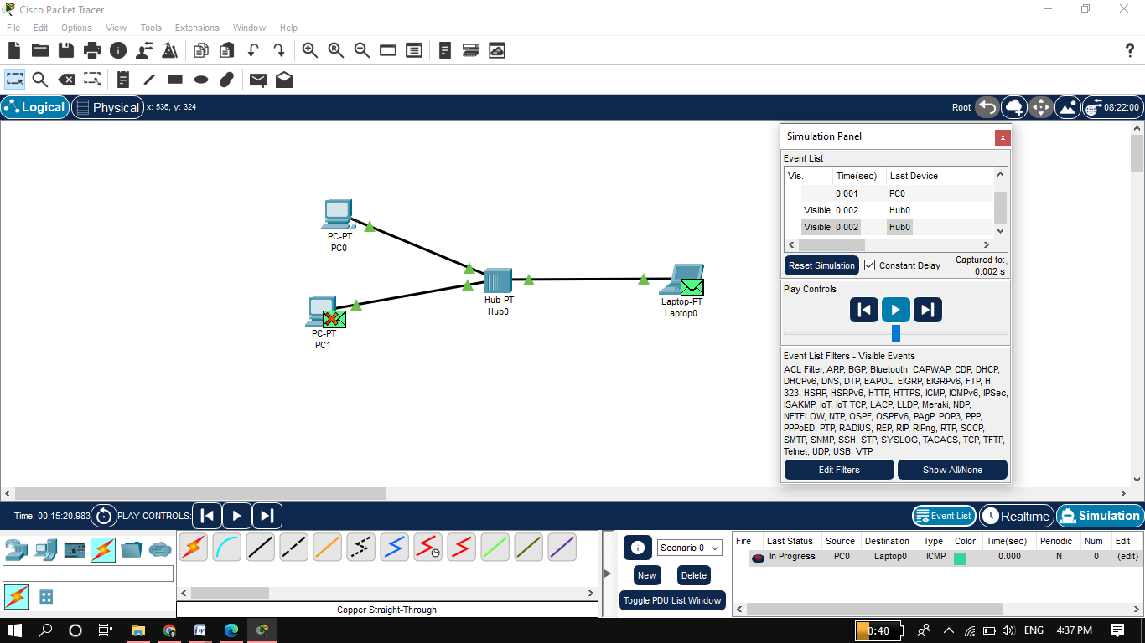

The laptop0 sent acknowledgment message back to HUB.

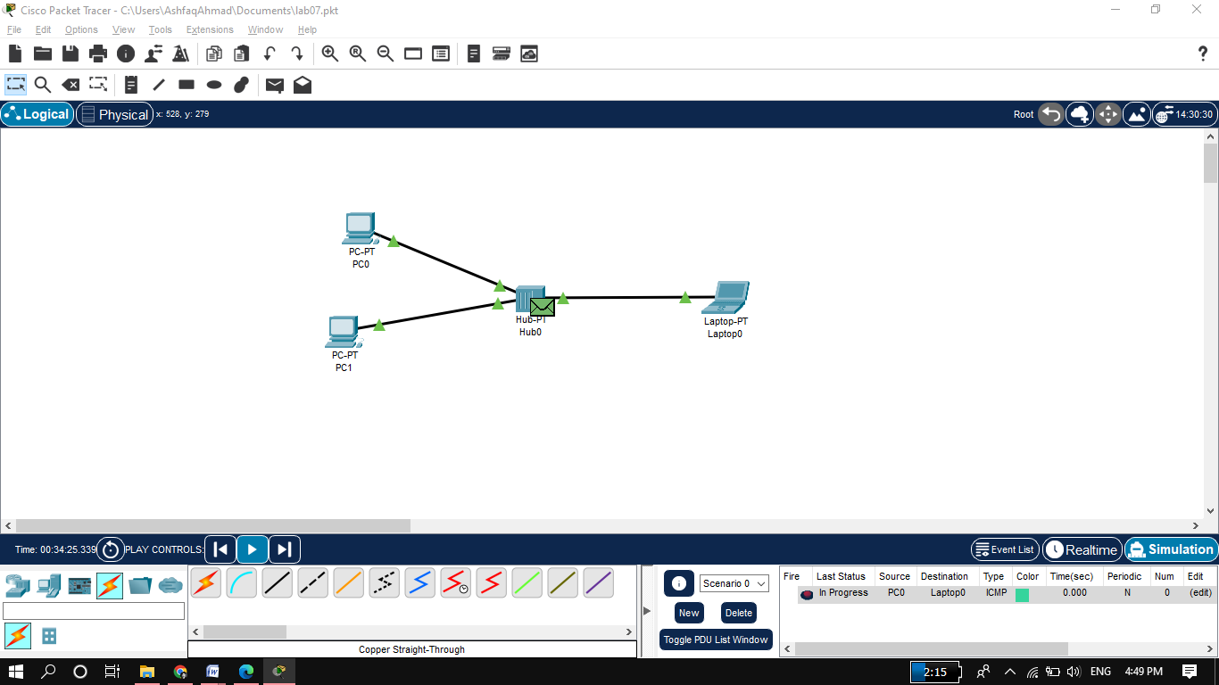

HUB again sent acknowledgment message to all PCs connected to it but accepted by only PC0

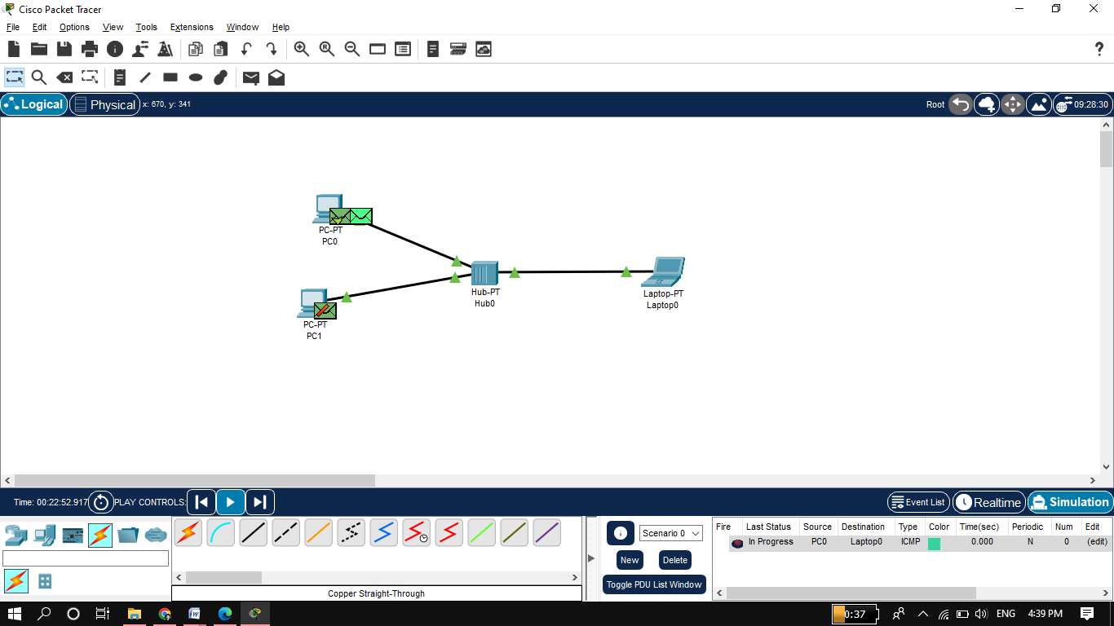

**Task 02:** Make LAN using SWITCH in Cisco Packet Tracer.

**LAN using Switch**

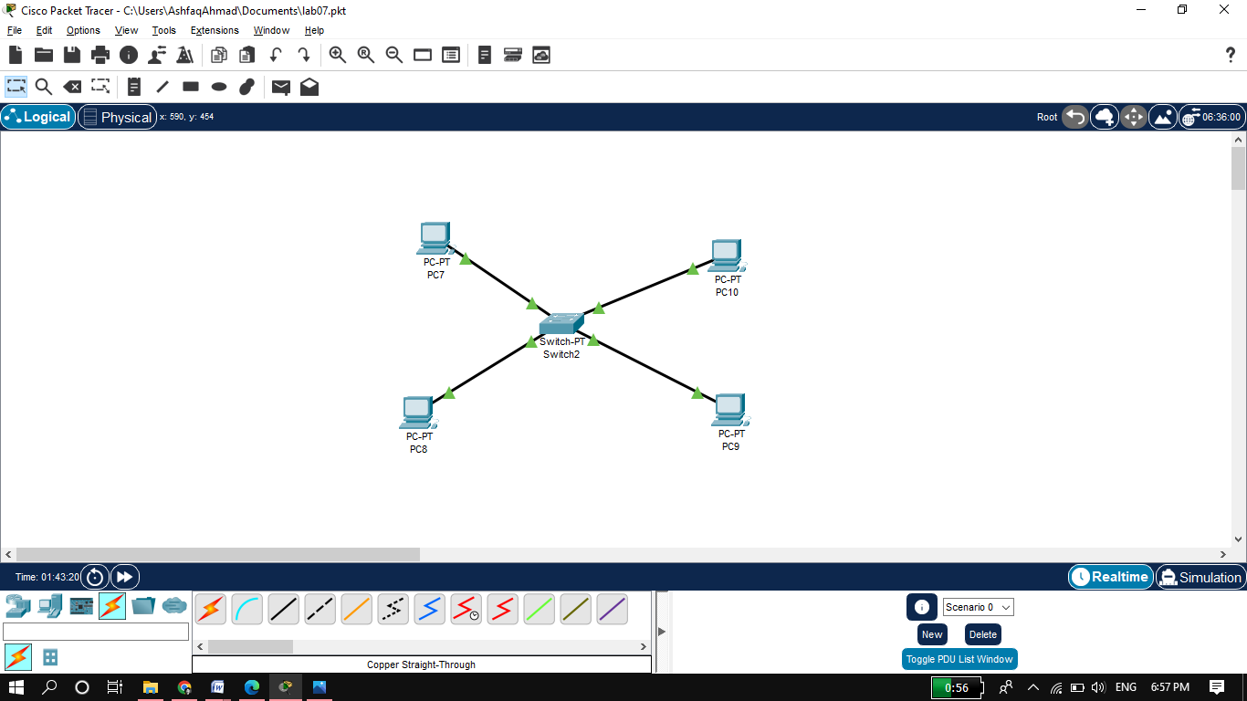

I want to send message from PC8 PC10. Message first sent to Switch.

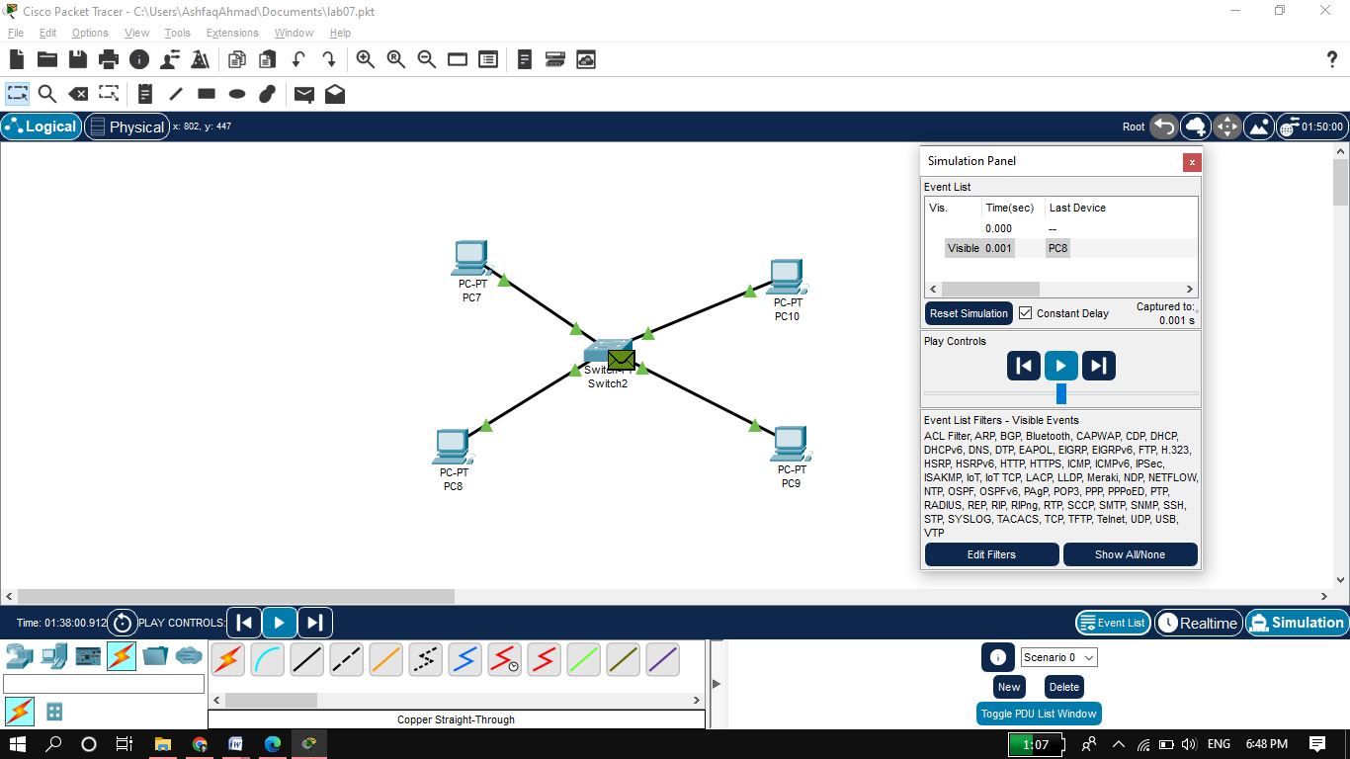

As switch is uni-cast so it sent to only targeted destination.

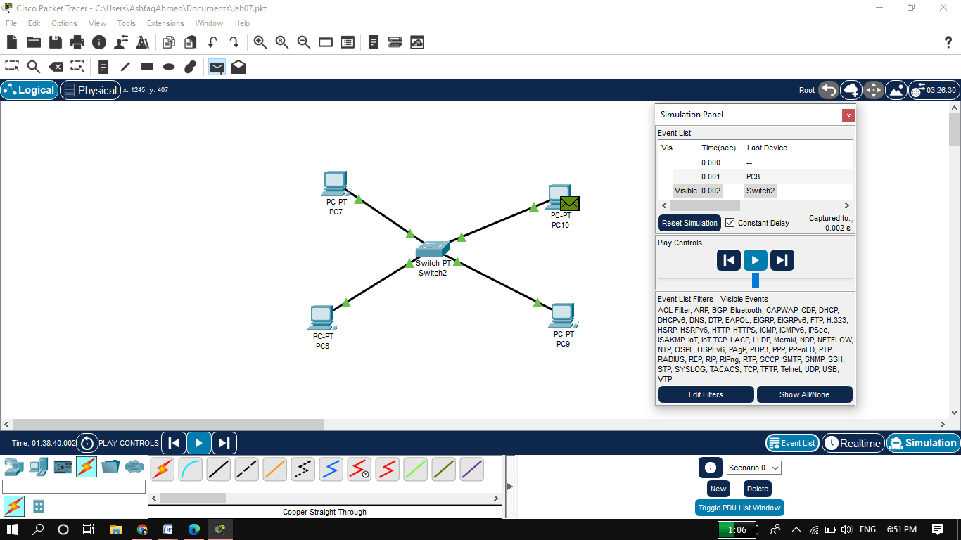

PC8 received acknowledgment message from receiver side.

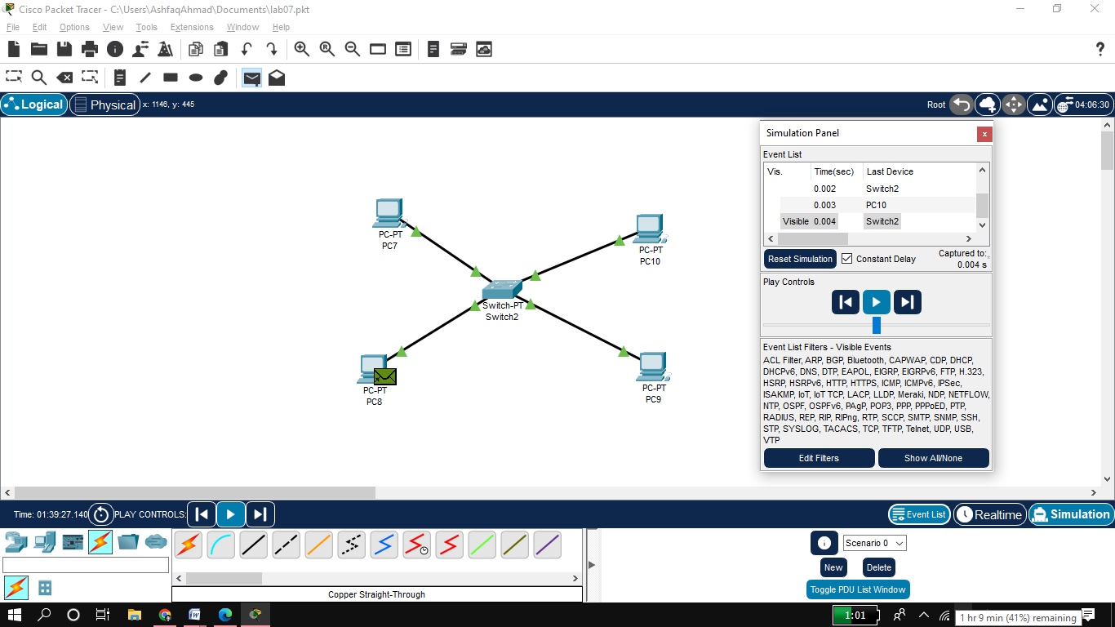

**Task03:** What are the pros and cons of HUB?

**PROS:**

* Good for data broadcasting.
* Less expensive
* Easy to implement.
* If one node become disordered doesn’t affect other nodes of the Network.

**CONS:**

* It's mostly half-Duplex
* We can’t send private message using HUB.
* Can’t provide Security to the data.
* Less intelligent.
* If Hub become disordered the whole network become disordered.
* Hub neither uses MAC address nor IP address of the nodes to send or receive data because it doesn’t make a sense.

**Task 04:** What are the pros and cons of SWITCH?

PROS:

* It’s for Uni-cast.
* Provide security to the data.
* More intelligent than HUB.
* Support full Duplex data transmission mode.
* Send or receive data using MAC address.
* One node fail doesn’t affect the rest part of the network.

CONS:

* expensive
* If switch become disorder the whole network become disorder.
* Difficult to setup.
* Can’t used for broadcasting.

**Task 05:** Which Ethernet cable did you use for the connection between HUB and PC?

**Answer:** As Hub and PC are two different devices so I used copper straight-through cable.

**Task 06:** What does a switch store in its memory?

**Answer:** Switch store MAC address and Port number of each device connected to it in its memory.